**Expert ID/Name: Nstructive**

**Date: 05-Nov-2020**

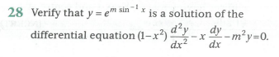

**Answer:**

|  |
| --- |
| **Section 1:** Algorithm/Theorem Reminder / A tip for solving these type of questions |
| Tips:  Differentiate the function  with respect to “x” on both sides in two times.  Substitute the value of  in simplification of second order differential equation . |

|  |
| --- |
| **Section 2:** Step-by-step answer |
| Given:  To verify: The function  is a solution of differential equation  Explanation:  Step 1:   |  |  | | --- | --- | | Instruction | Take and do differentiate with respect to “x” on both sides. | | Calculation |  |   Step 2:   |  |  | | --- | --- | | Instruction | Differentiate with respect to “x” and apply | | Calculation |  | |

|  |
| --- |
| Conclusion: The function  is a solution of differential equation |
| Hence, verified. |